Tutorial 5.3

Stan Wan

### 

### Step 1: Stimulation setup

The codes follow the leaky integrate and fire equations for the membrane potentials, 𝑉1 and 𝑉2 of the two cells. (line 1 - 67)

For spikes: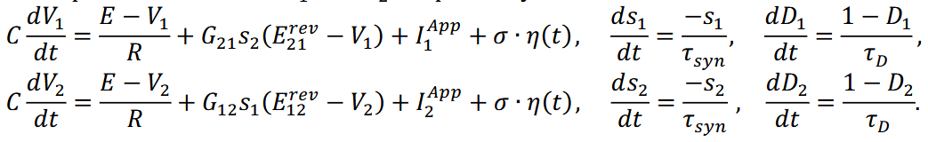



### Step 2: Stimulation with extra current pulses

Stimulated for 6s and a **100 ms of 3nA pulse** for each cell. Plotted the membrane potential and the synaptic gating variables against time. (line 70 - 90)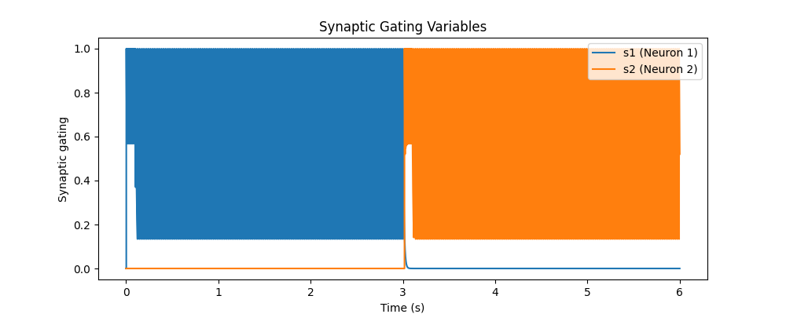

The synaptic gating variable (s1 and s2) exhibits clear bistability.

Initially, neuron 1 (blue) is dominant, with s1 ≈ 1 while s2 ≈ 0.

At around 3s, the system switches states, and neuron 2 (orange) takes over, with s2 ≈ 1 and s1 ≈ 0. The transition is sharp, which is expected in bistable systems.

The neuron membrane potentials also show bistability aligned with the first plot, where one neuron dominates for an extended period before switching.

Initially, neuron 1 (blue) is active, while neuron 2 (orange) remains inhibited.

At around 3s, a switch occurs, and neuron 2 becomes dominant for 3s, caused by the 100ms of 3nA external current.

The firing pattern is dense, meaning the neurons are firing regularly at their threshold.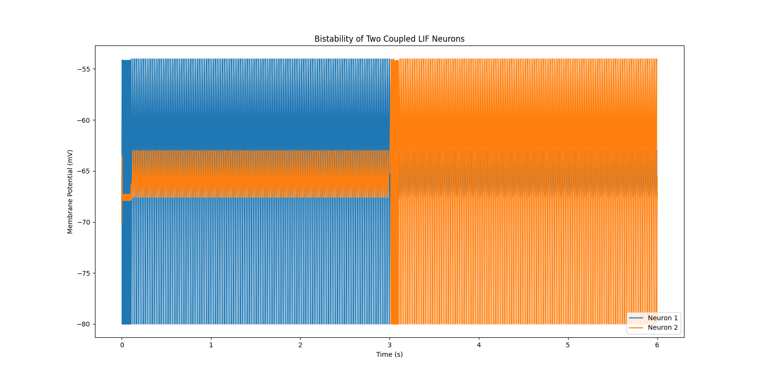

### Step 3: Noise addition

Set the **noise** variable sigma to 50pA. Simulated for 6s again with **only baseline current**. (line 102 -128)

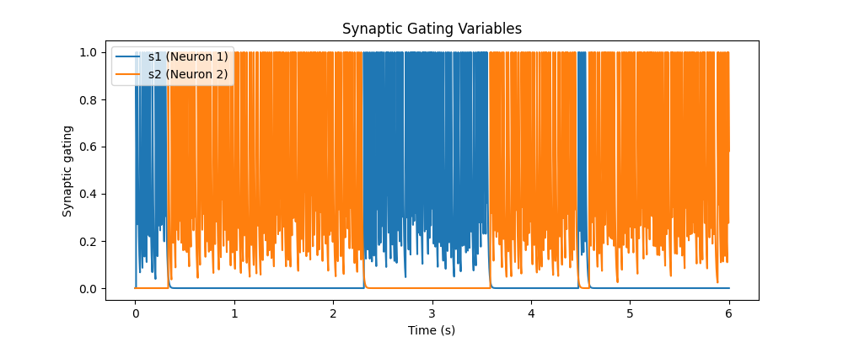

In contrast to the previous bistable case, this plot now shows frequent **switching**, 5 times, between states.

s1 (blue) and s2 (orange) alternate irregularly, indicating noise-driven state changes.

Instead of maintaining a dominant state for long durations, the system is now transitioning rapidly. The high added noise causes the transitions to happen frequently, disrupting bistability.

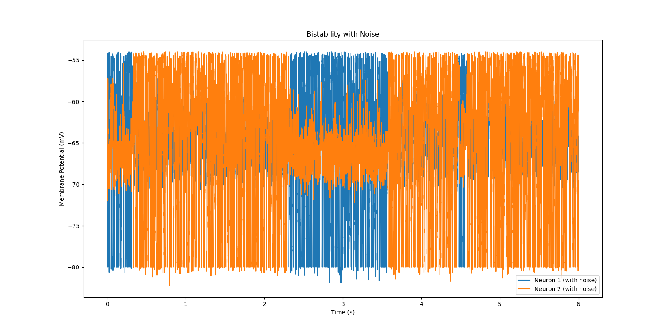

The result in the Membrane potential v.s. Time graph aligns with that in the gating variable graph. And clearly noise was effectively applied so that the membrane potentials are not completely the same each spike. More switches happen which indicates the results to be noise dominant.

### Step 4: State Duration Histogram (line 131 - 165)

Step a new vector to record state-switching.Stimulated for 60s and plotted a histogram of the duration in each state.

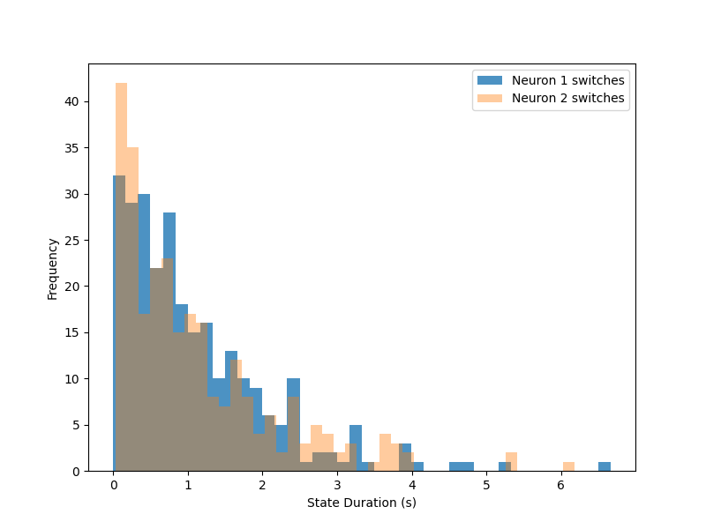

The histogram shows the distribution of time spent in each state before switching. The most frequent durations are very short (<1s), with a gradual decline for longer durations. Both neurons exhibit a similar distribution. Some longer durations (3-6s) exist but are rare, indicating occasional extended dominance.

The exponential-like distribution makes sense since no depression has been applied.

### Step 5: Stimulation with Depression variables (line 168 - 198)

Repeated step 2 but set the depression variable pR to 0.2.

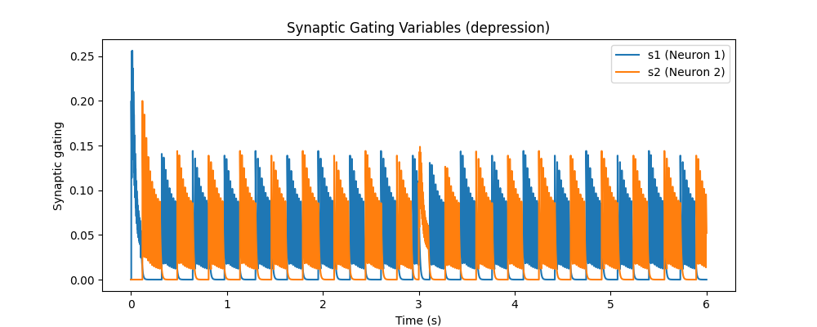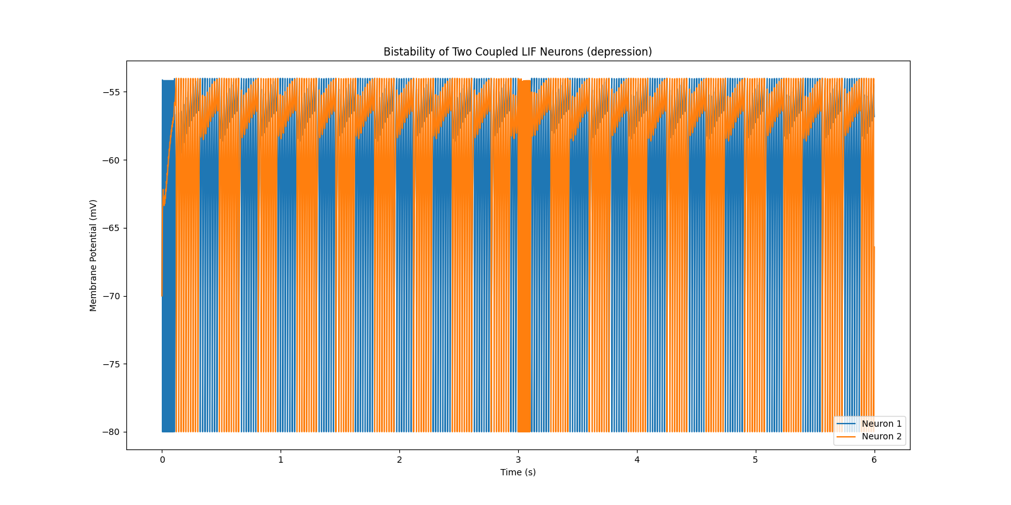

Compared to previous results, s1 and s2 now decay after each activation, showing the effects of synaptic depression. The system exhibits oscillatory switching, with more regular alternation between the neurons. The peaks gradually stabilize, indicating a steady rhythm

There are no prolonged dominance periods in membrane potentials, which confirms the impact of synaptic depression.

### Step 6: State Duration with Synaptic Depression (line 201 - 217)

Repeated step 4 but added a smaller noise, sigma = 5pA.

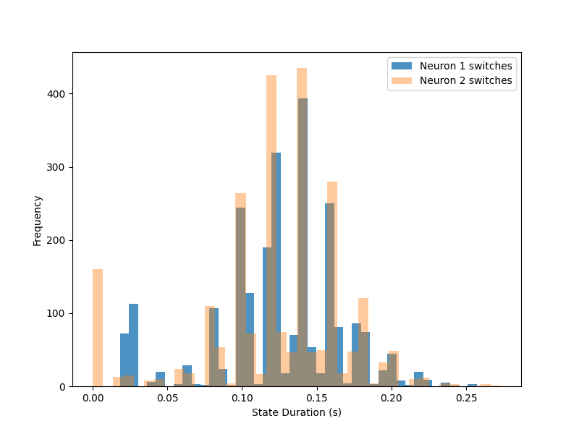

The distribution is more peaked compared to the bistable case without synaptic depression, and loses its exponential distribution.

State durations cluster around 0.1 - 0.15s, showing a more predictable oscillation pattern.

There are fewer extremely short or long state durations, meaning the system is less affected by noise-driven fluctuations.